Sum of Fibonacci series

#include<stdio.h>

main()

{

int i,n,f1=0,f2=1,f3,temp,sum=0;

printf("enter the value of n\n");

scanf("%d",&n);

printf("\n %d \n ",f1,f2);

for(i=0;i<=n;i++)

{

f3=f1+f2;

printf("%d\n",f3);

temp=f1;

f1=f2;

f2=f3;

sum=sum+f2;

}

printf("the sum is =%d",sum);

}

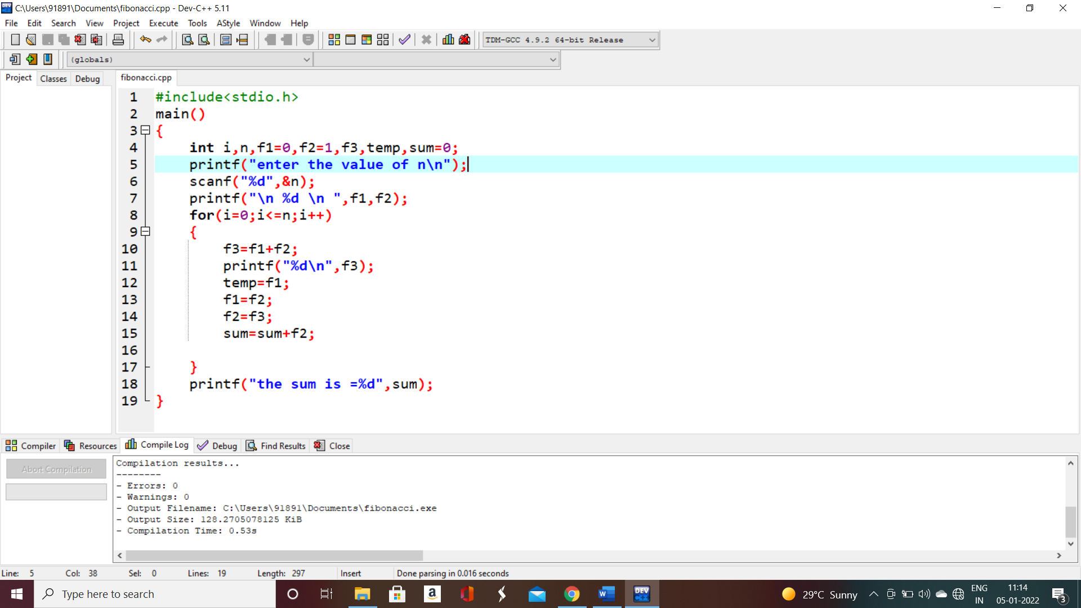

.

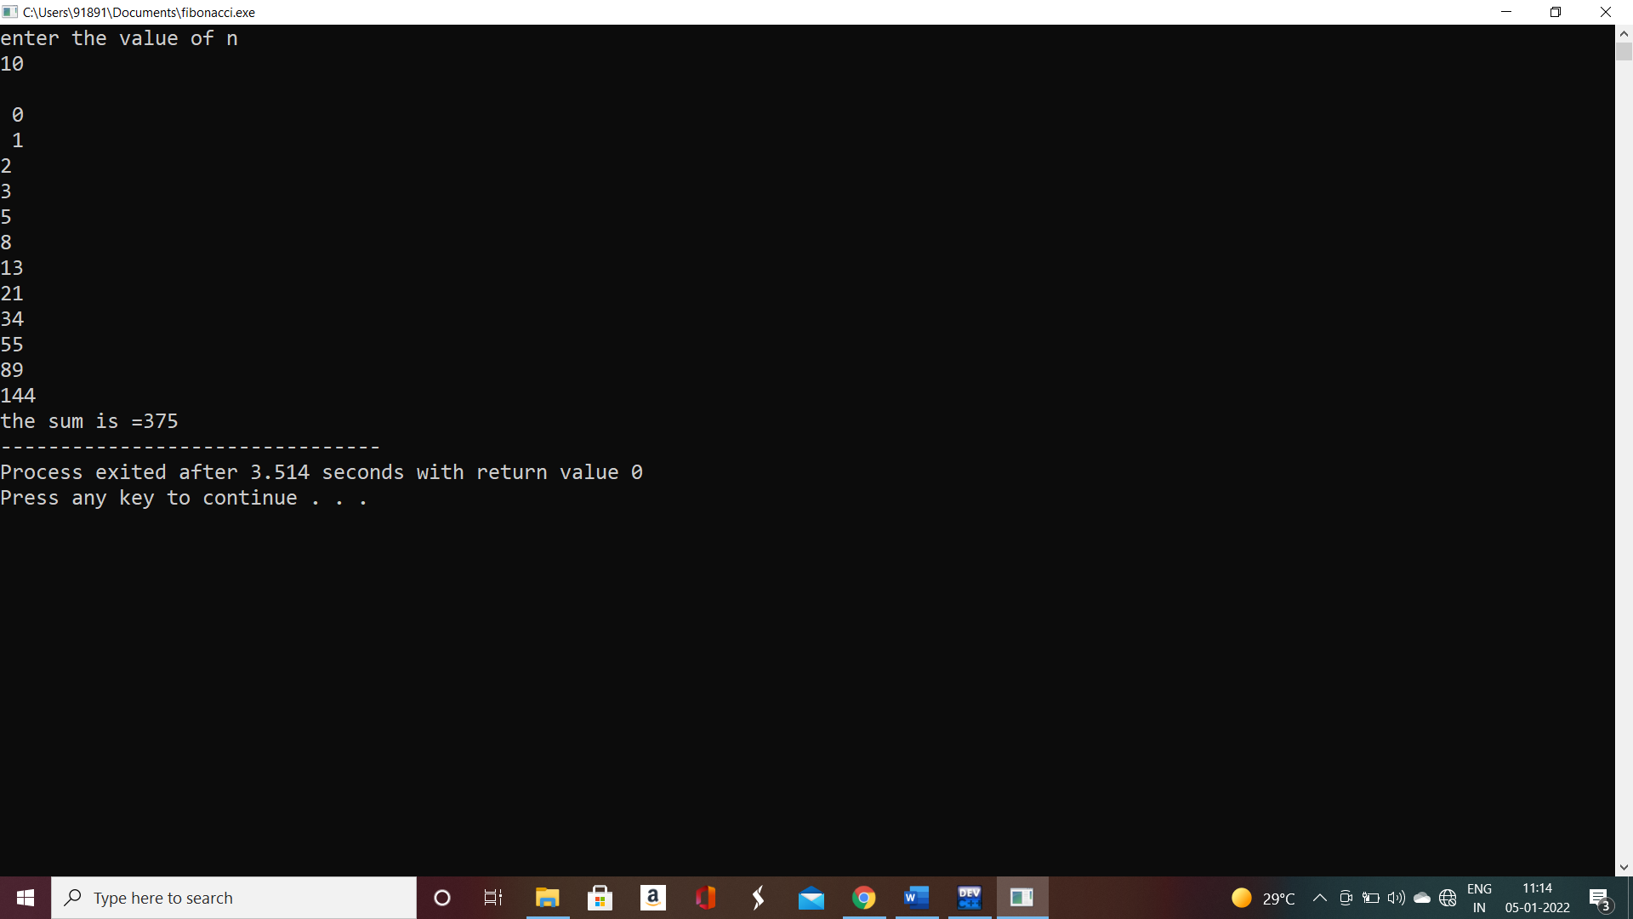

Summing of series

#include<stdio.h>

main()

{

int a=1,sum=0,n;

printf("enter the value of n");

scanf("%d",&n);

while(a<=n)

{

sum = sum+a;

a=a+1;

}

printf("%d",sum);

}

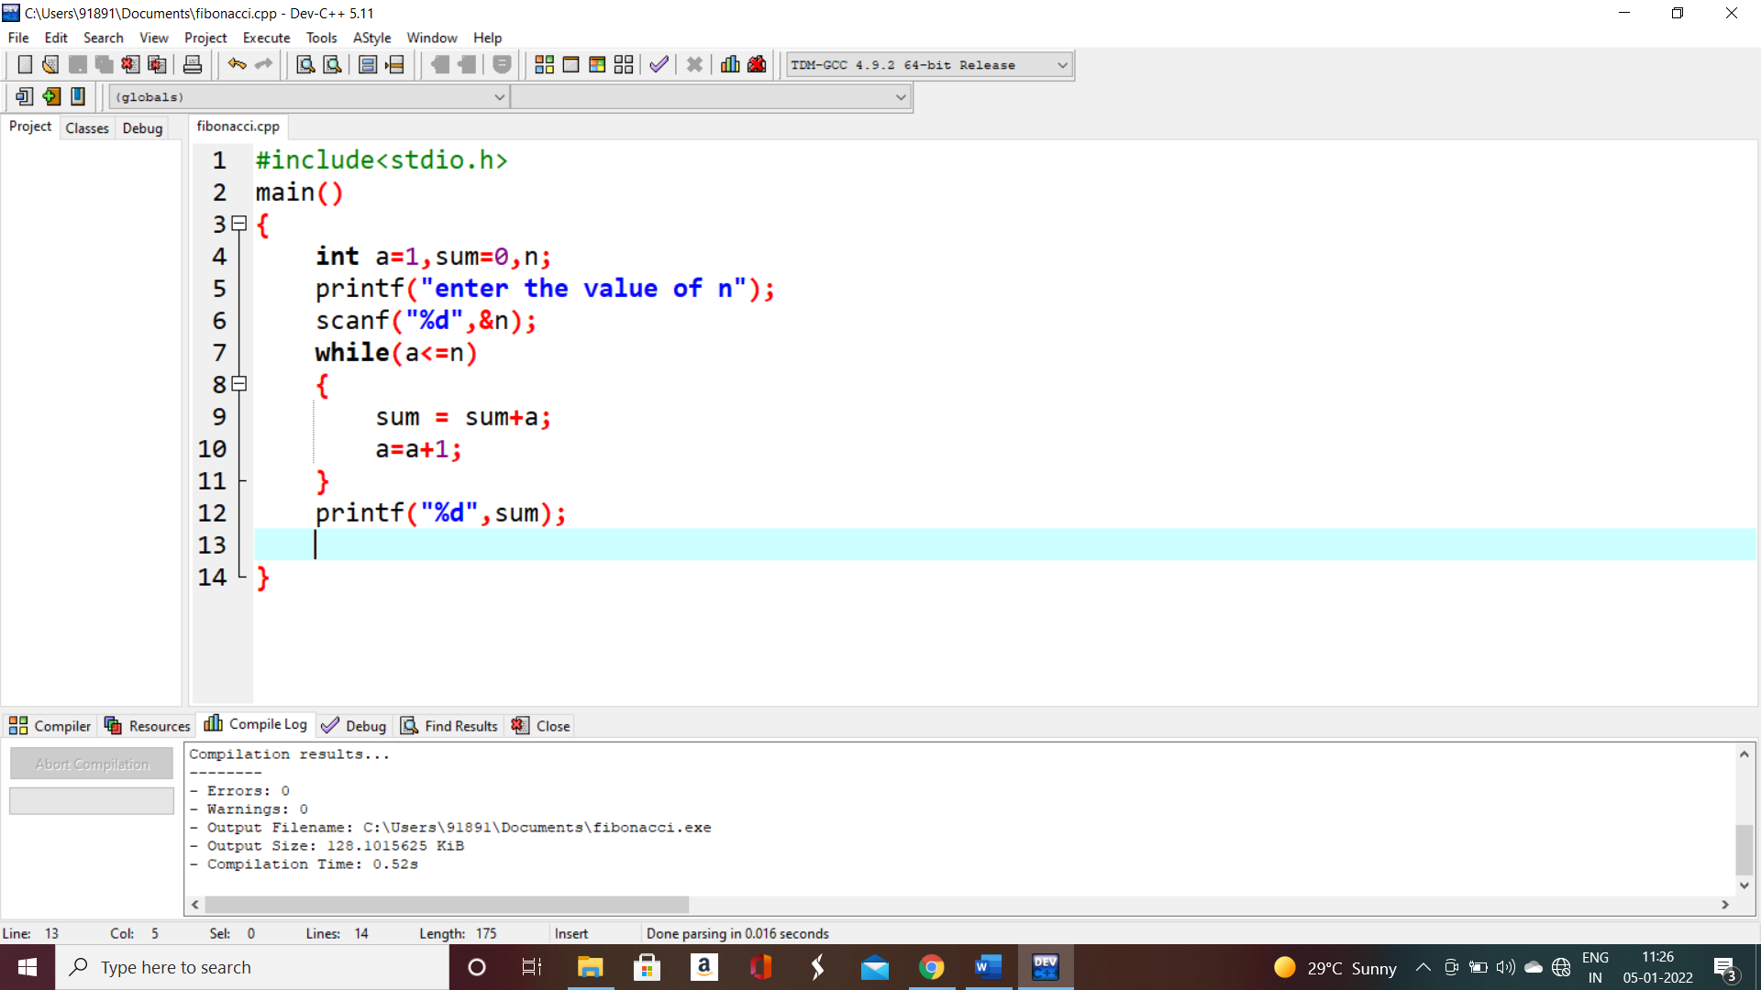

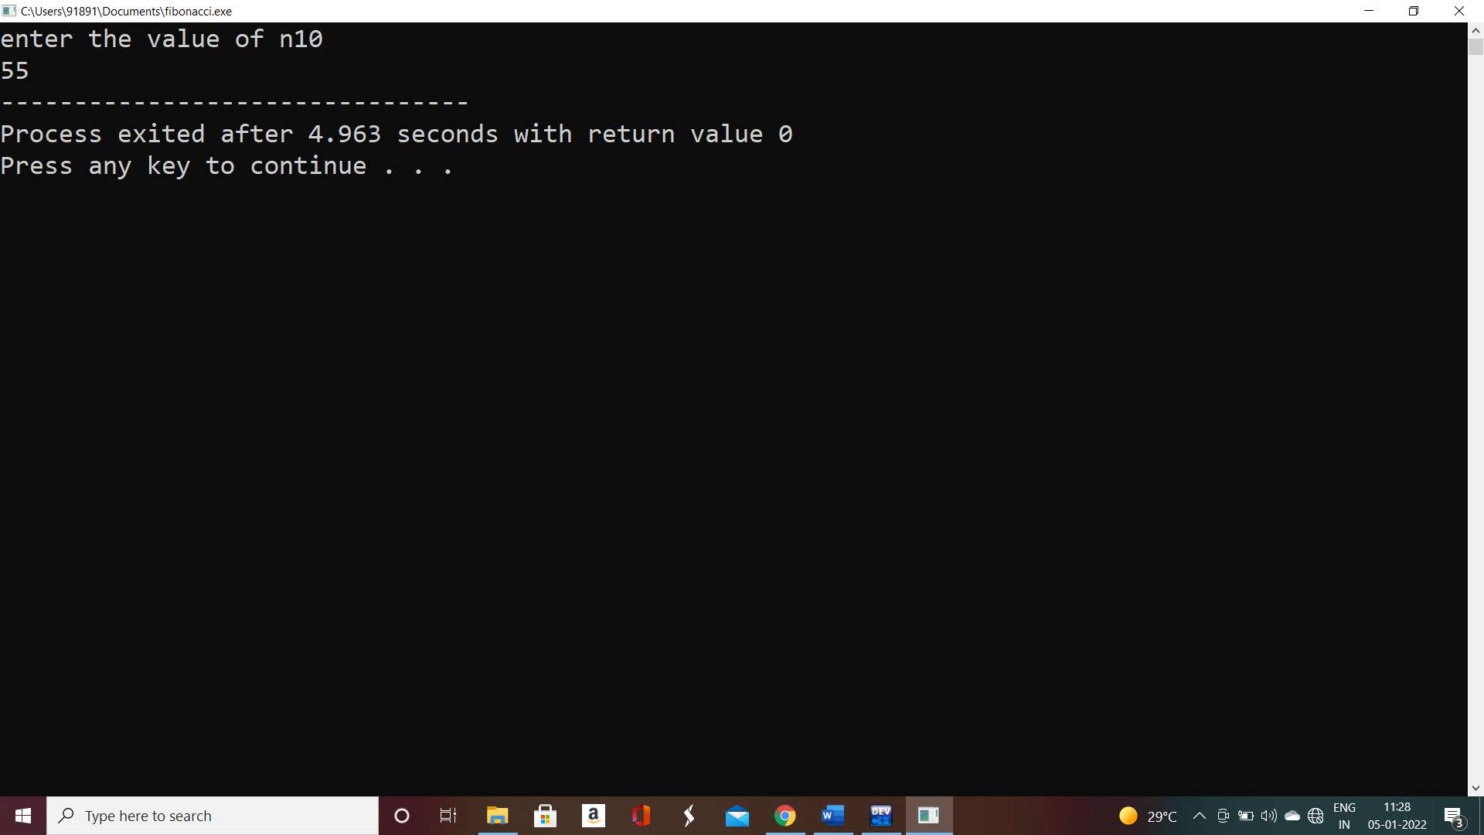

Summing of odd numbers

#include<stdio.h>

main()

{

int a=1,sum=0,n;

printf("enter the value of n\n");

scanf("%d",&n);

while(a<=n)

{

sum = sum+a;

a=a+2;

}

printf("%d",sum);

}

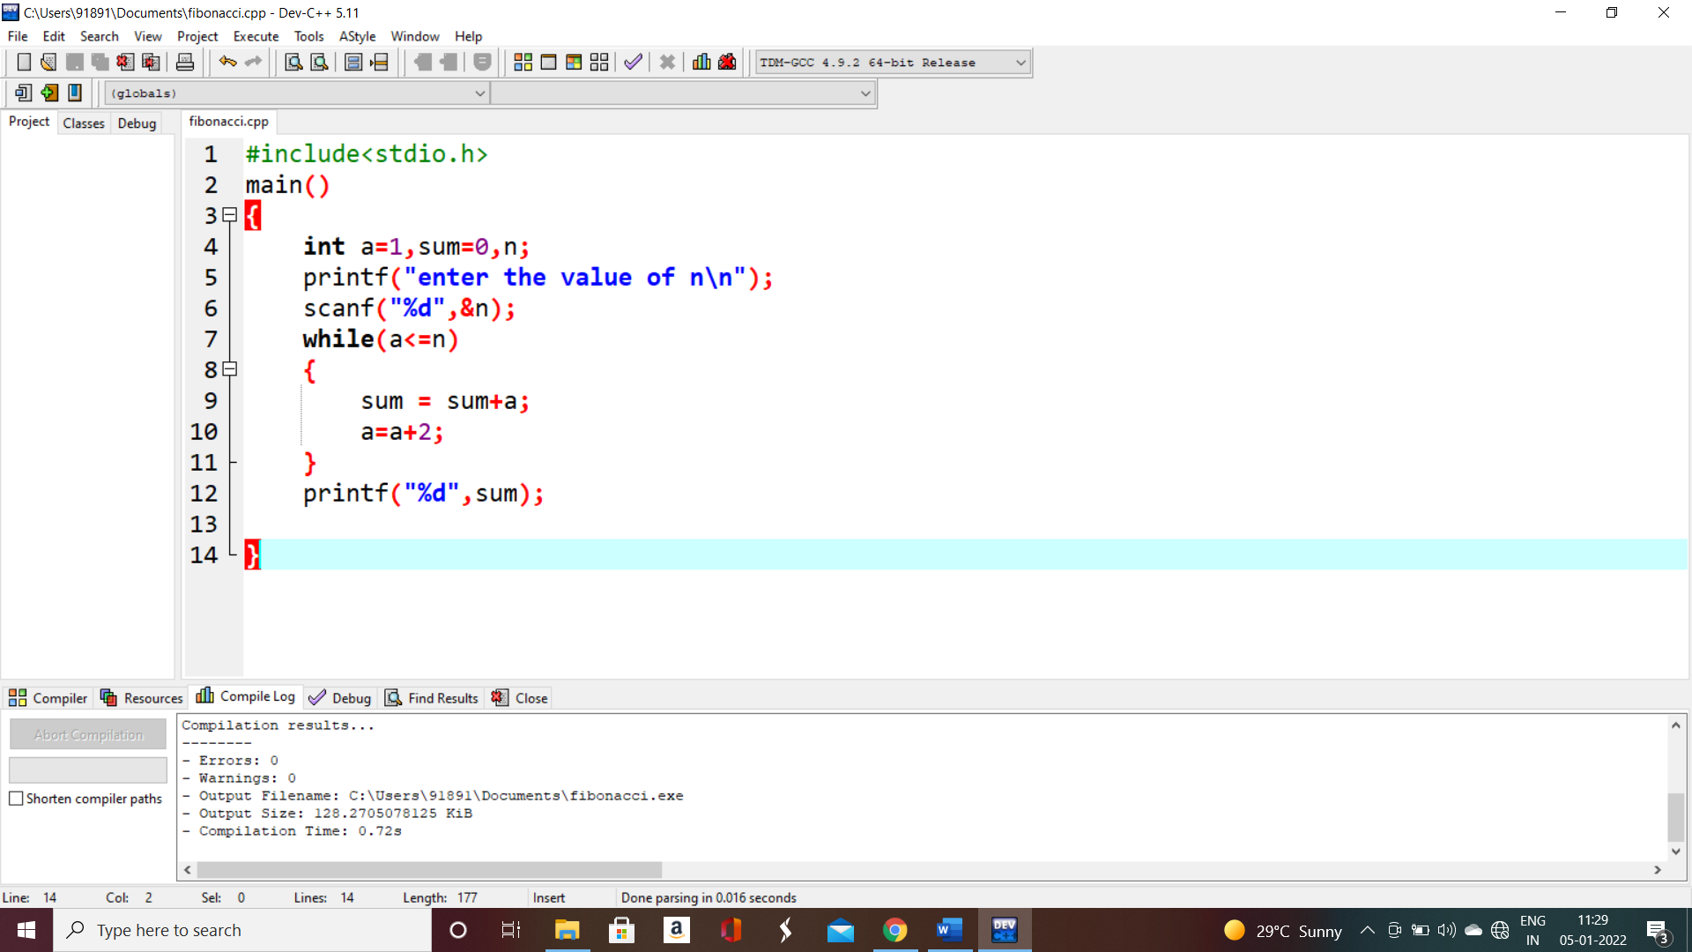

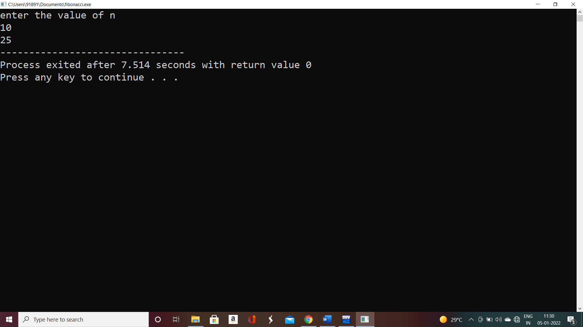

Summing of even series:

#include<stdio.h>

main()

{

int a=0,sum=0,n;

printf("enter the value of n\n");

scanf("%d",&n);

while(a<=n)

{

sum = sum+a;

a=a+2;

}

printf("%d",sum);

}

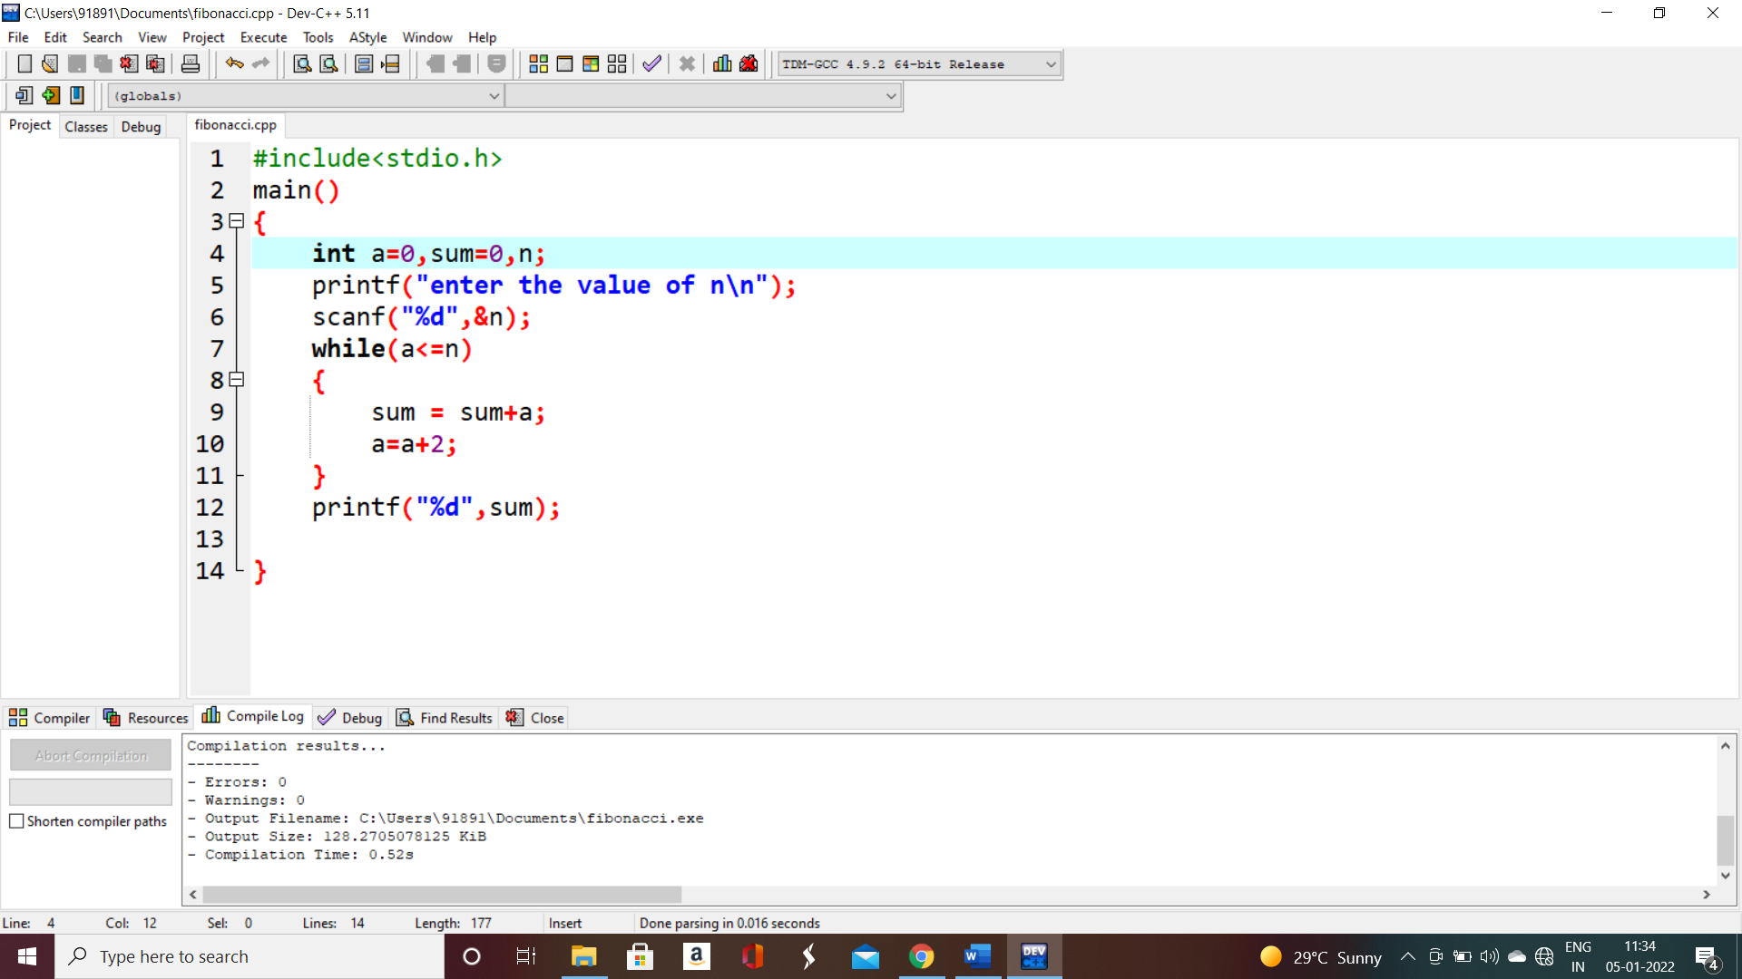

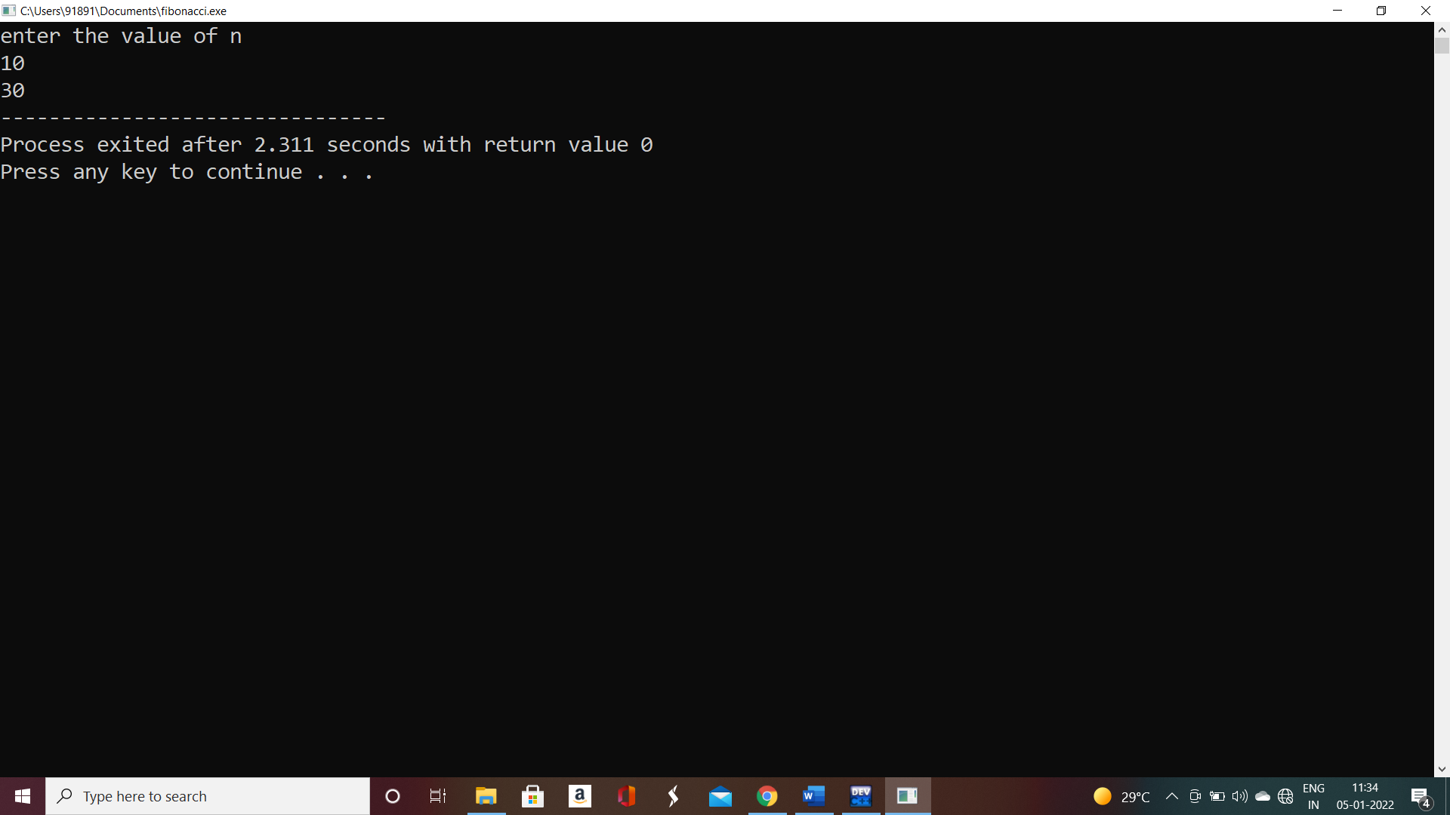

Summing of 1-2+3-4+5-6+7……

#include<stdio.h>

main()

{

int i,sum=0,n;

printf("enter the value of n\n");

scanf("%d",&n);

for(i=1;i<=n;i++)

{

if(i%2!=0)

{

sum=sum+i;

}

else

{

sum=sum-i;

}

}

printf("sum=%d",sum);

}

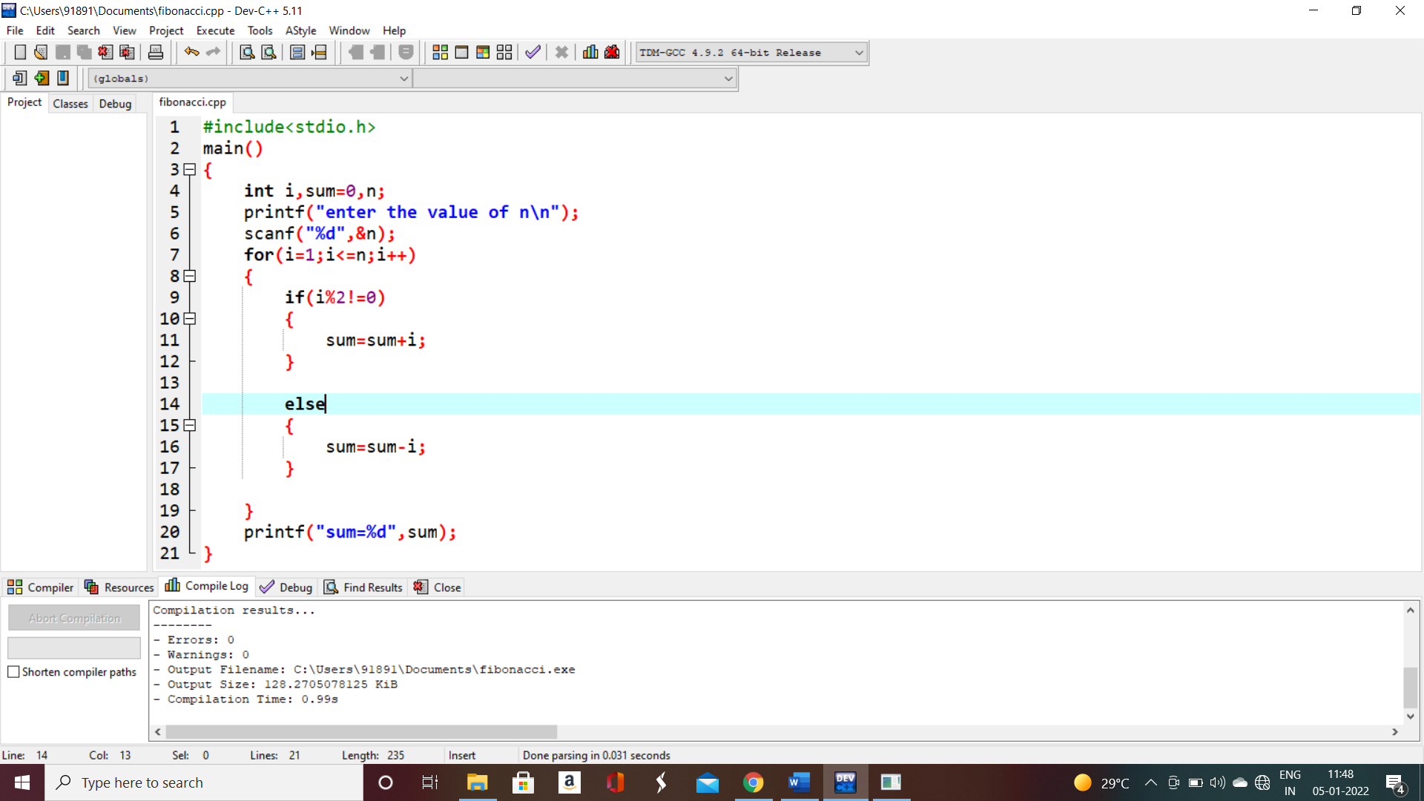

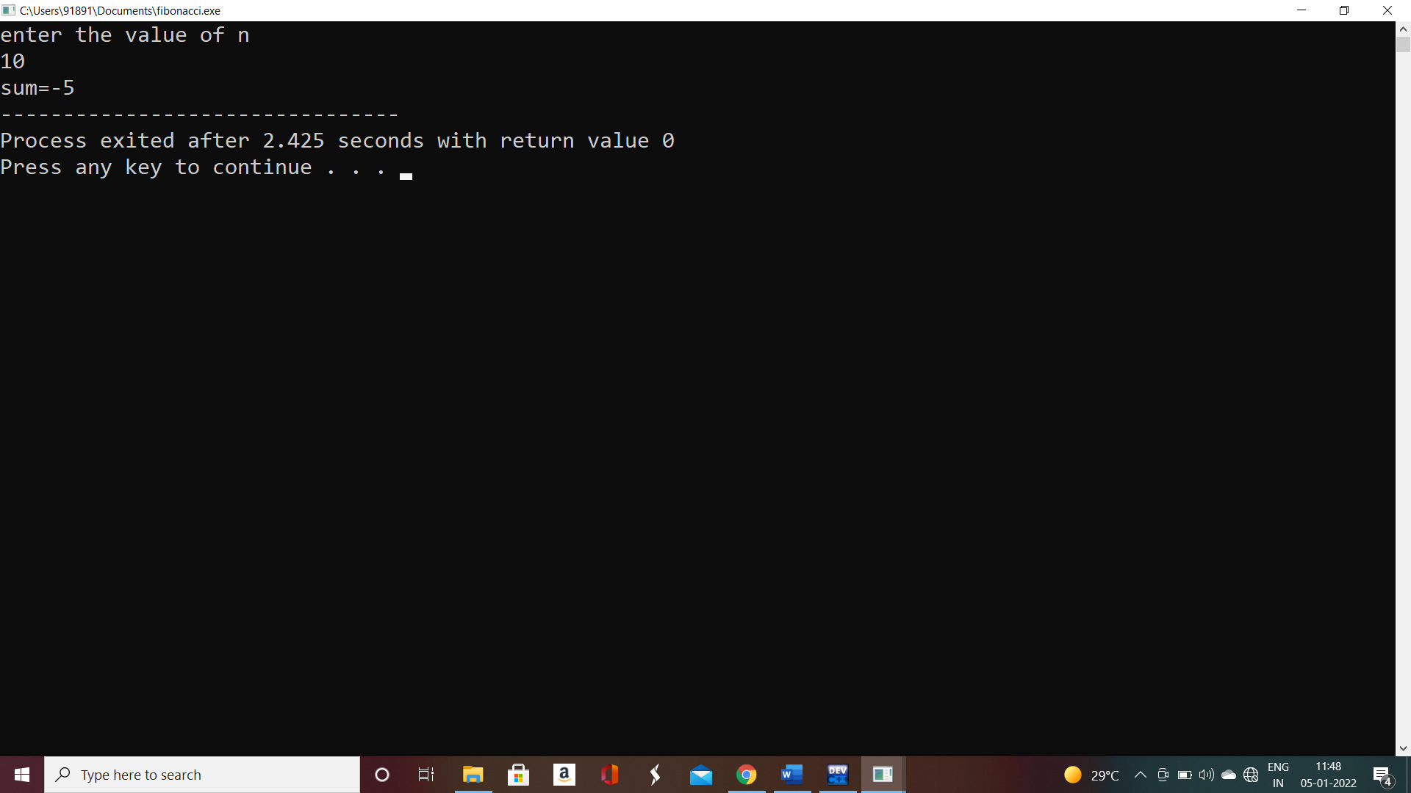

11.

#include<stdio.h>

#include<math.h>

int main()

{

int a,i=1,sum=0,n,result;

printf("enter the value of n\n");

scanf("%d",&n);

for(a=1;a<=n;a++)

{

result = pow(a,i);

sum=sum+result;

i++;

}

printf("%d",sum);

return(0);

}

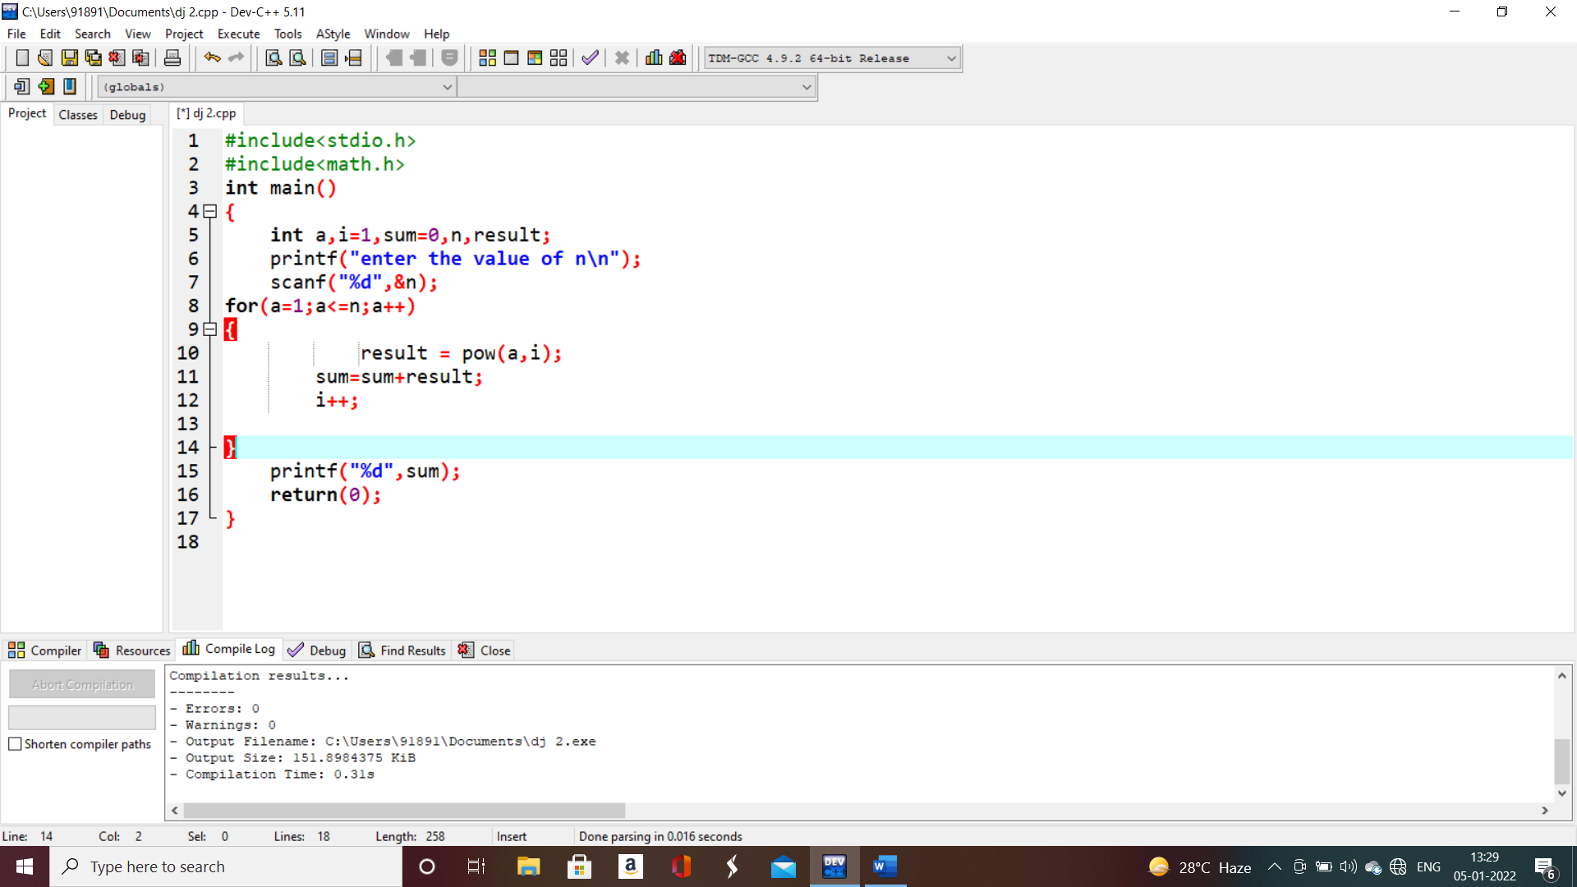

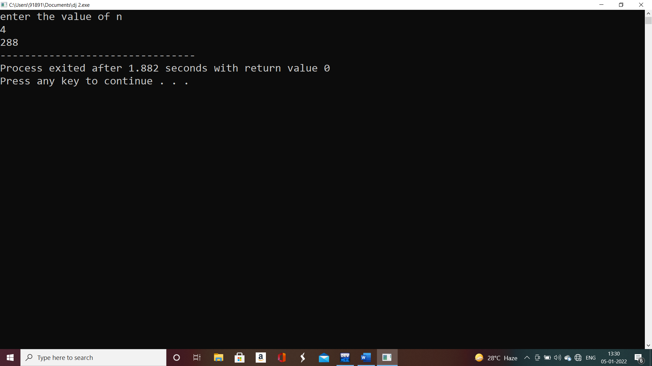

12. sum of squares of odd number

#include<stdio.h>

main()

{

int a=1,sum=0,n;

printf("enter the value of n\n");

scanf("%d",&n);

while(a<=n)

{

sum = sum+(a\*a);

a=a+2;

}

printf("%d",sum);

}

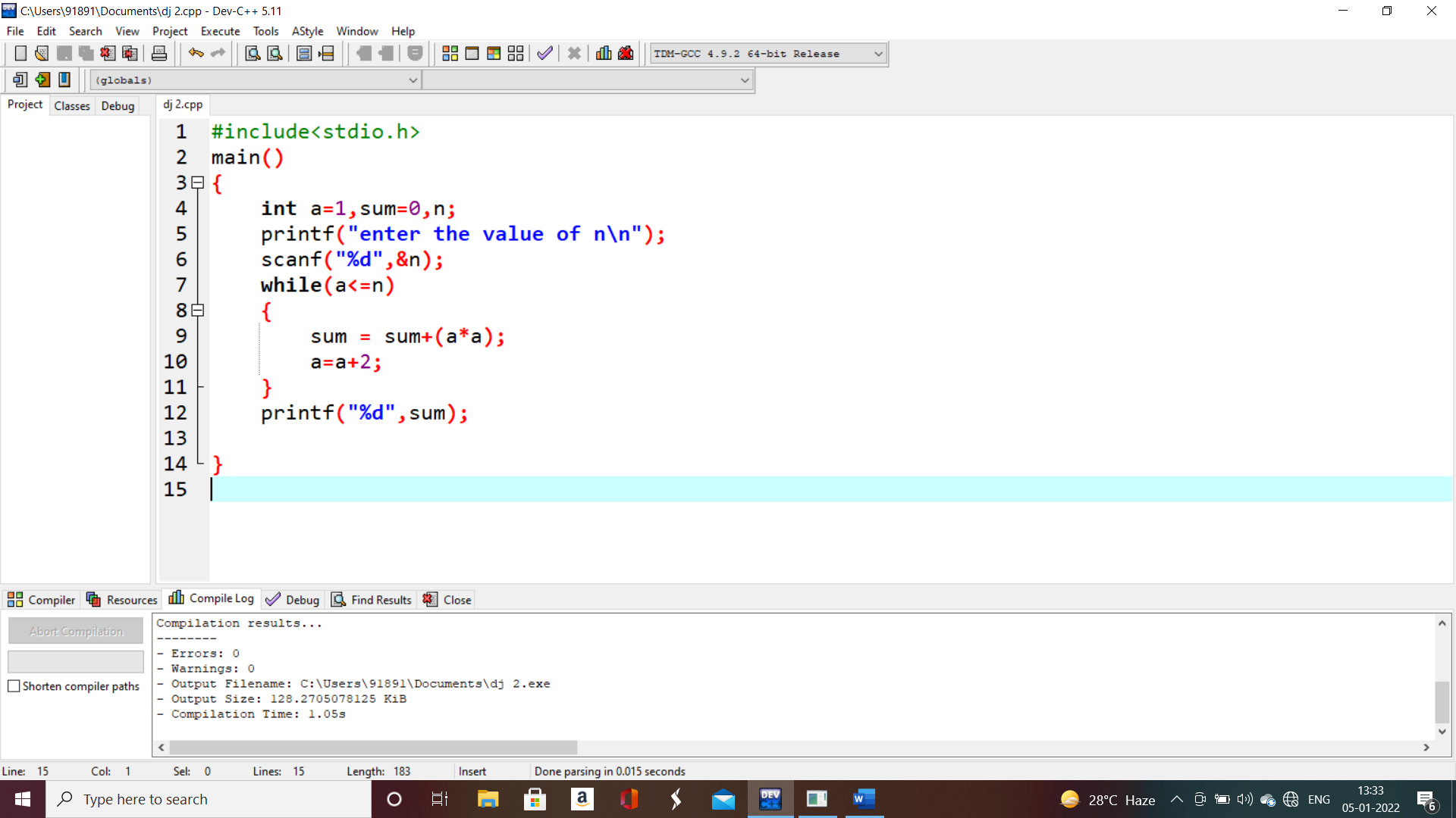

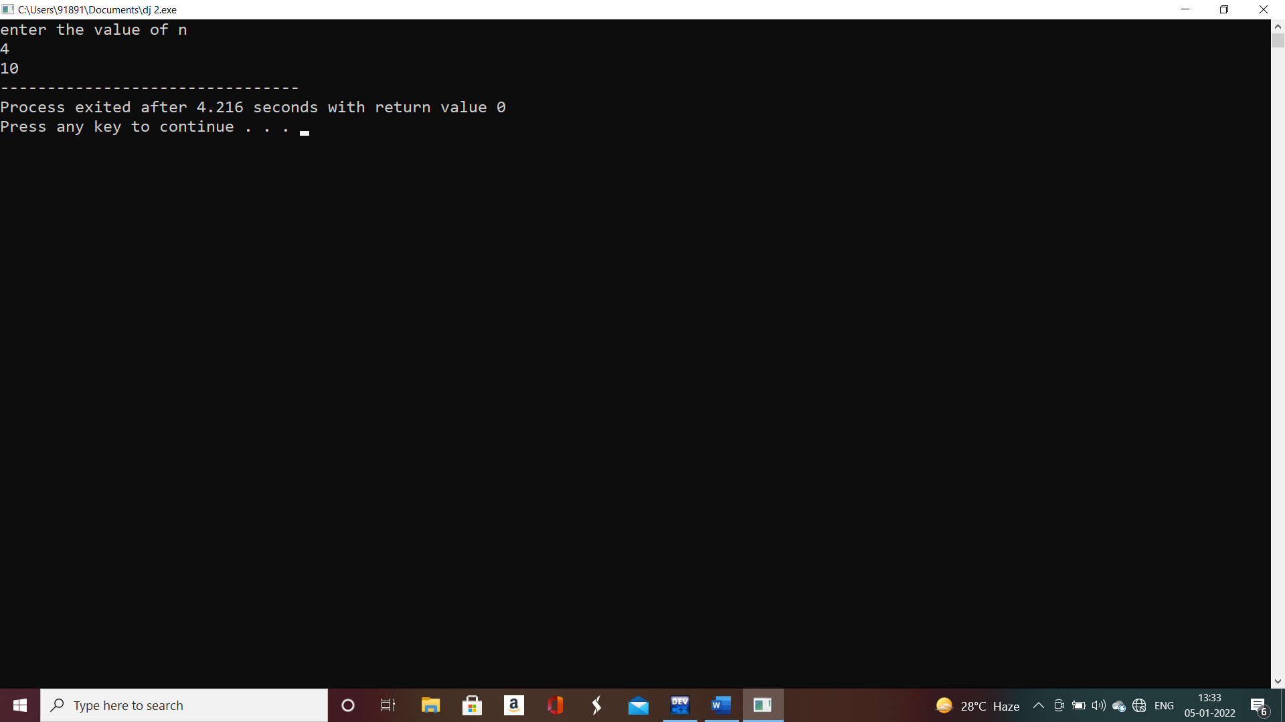

13. sum of cubing of numbers

#include<stdio.h>

main()

{

int a=1,sum=0,n;

printf("enter the value of n\n");

scanf("%d",&n);

while(a<=n)

{

sum = sum+(a\*a\*a);

a=a+1;

}

printf("%d",sum);

}

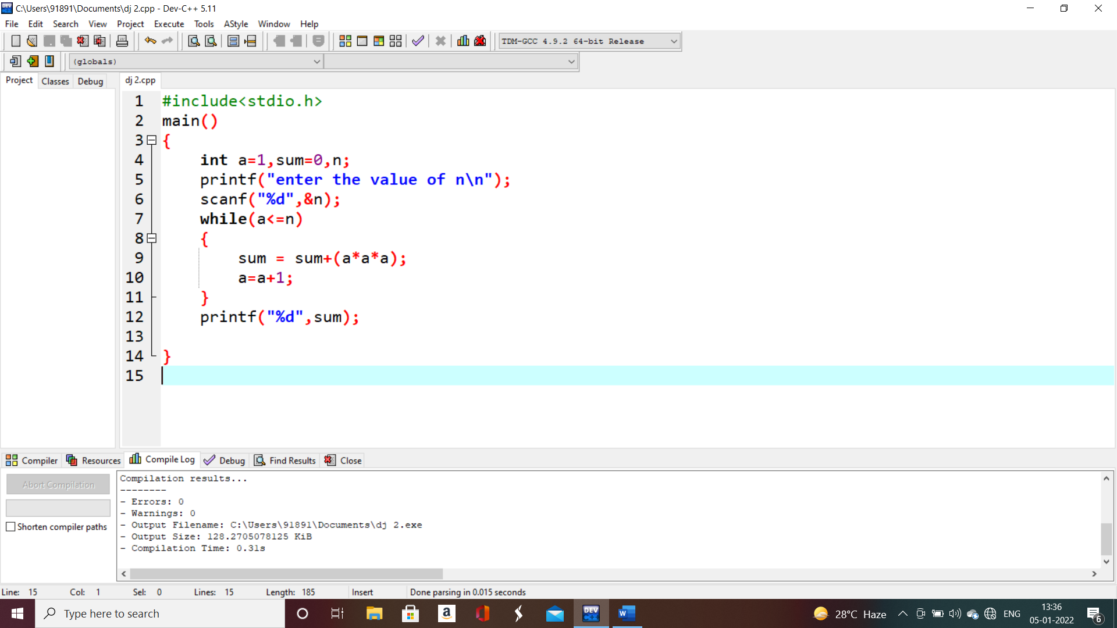

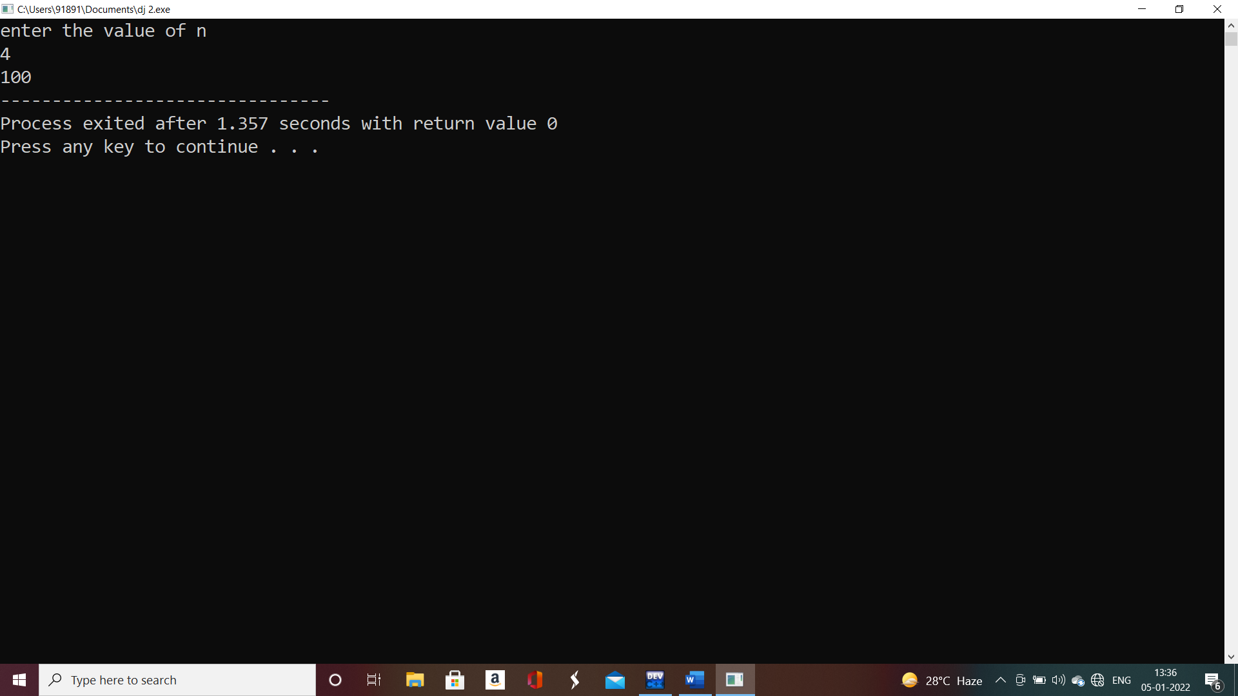

14. product series (factorial of given number)

#include<stdio.h>

main()

{

int a=1,fact=1,n;

printf("enter the value of n\n");

scanf("%d",&n);

for(a=1;a<=n;a++)

{

fact=fact\*a;

}

printf("%d",fact);

}

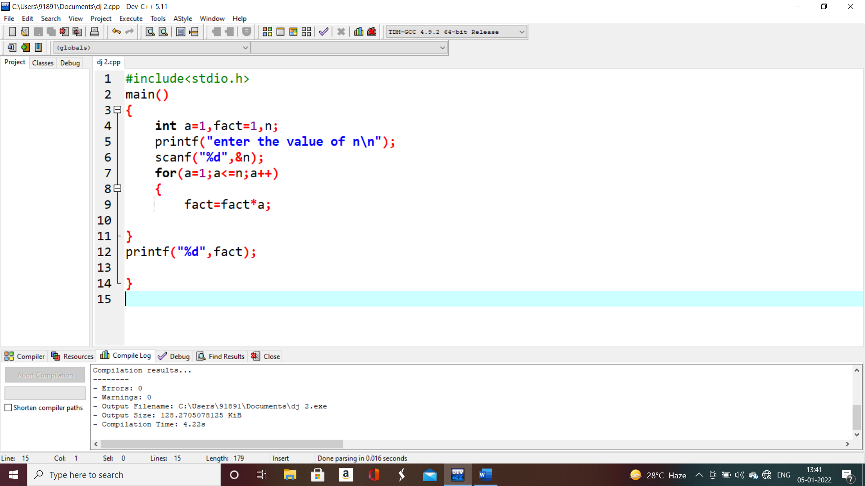

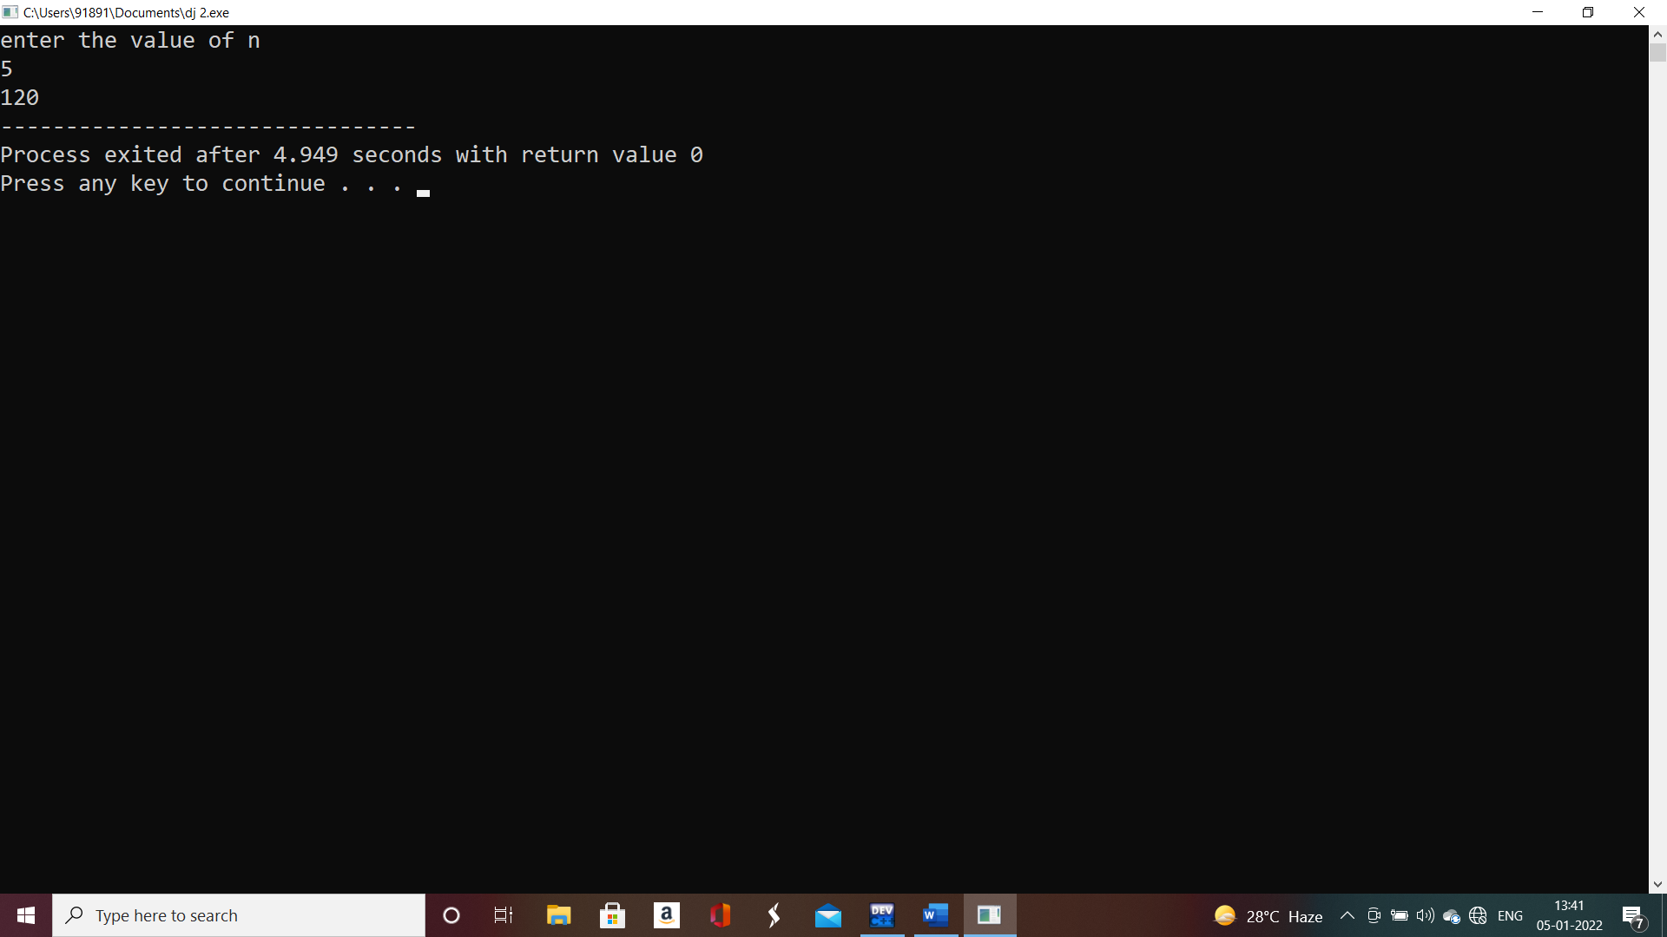

15 armstrong number

#include<stdio.h>

main()

{

int num,d,n,sum=0;

printf("enter the number\n");

scanf("%d",&n);

num=n;

while(num!=0)

{

d=num%10;

sum=sum+d\*d\*d;

num=num/10;

}

if(sum==n)

{

printf("%d is an armstrong number:",n);

}

else

{

printf("%d is not an armstrong number:",n);

}

}

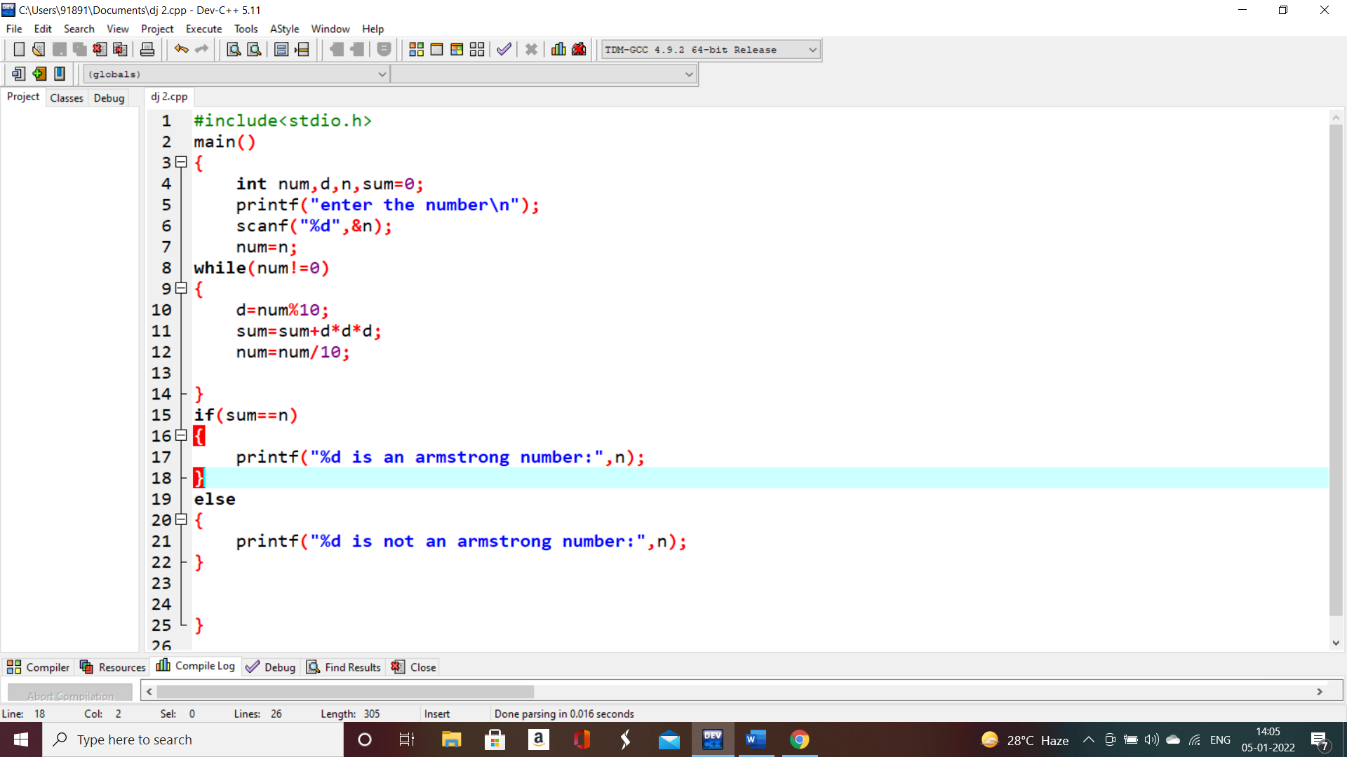

18.summing of digits

#include<stdio.h>

main()

{

int num,d,n,sum=0;

printf("enter the number\n");

scanf("%d",&n);

num=n;

while(num!=0)

{

d=num%10;

sum=sum+d;

num=num/10;

}

printf("%d ",sum);

}

19 . reversing a number

#include<stdio.h>

main()

{

int num,rem,rev=0;

printf("enter the number\n");

scanf("%d",&num);

while(num!=0)

{

rem=num%10;

rev=(rev\*10)+rem;

num=num/10;

}

printf("%d ",rev);

}

20. odd or even

#include<stdio.h>

main()

{

int n;

printf("enter the value of n");

scanf(" %d",&n);

if(n%2==0)

{

printf("even number");

}

else{

printf("odd number");

}

}

21. positive or negative

#include<stdio.h>

main()

{

int n;

printf("enter the value of n");

scanf(" %d",&n);

if(n>=0)

{

printf("positive number");

}

else{

printf("negative number");

}

}

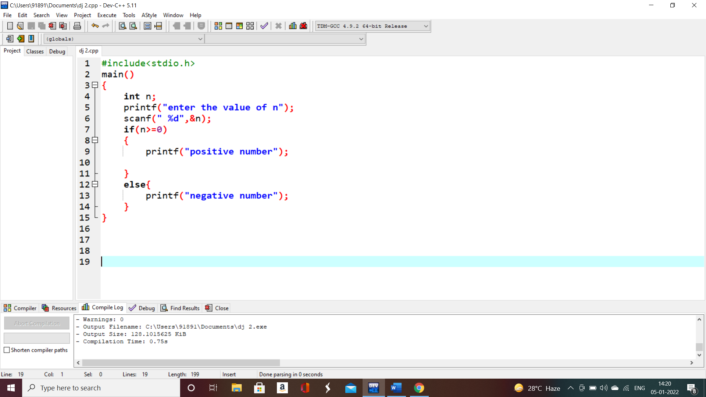

22 : swapping of a two number

#include<stdio.h>

main()

{

int t1,t2,temp;

printf("enter the value of t1\n");

scanf(" %d",&t1);

printf("enter the value of t2\n");

scanf("%d",&t2);

temp=t1;

t1=t2;

t2=temp;

printf("%d %d",t1,t2);

}

23. swapping of two number without temporary variable

#include<stdio.h>

main()

{

int num1,num2;

printf("enter the value of num1\n");

scanf(" %d",&num1);

printf("enter the value of num2\n");

scanf("%d",&num2);

num1=num1+num2;

num2=num1-num2;

num1=num1-num2;

printf("%d %d",num1,num2);

}

24. swapping of 3 numbers

#include<stdio.h>

main()

{

int num1,num2,num3;

printf("enter the value of num1\n");

scanf(" %d",&num1);

printf("enter the value of num2\n");

scanf("%d",&num2);

printf("enter the value of num3\n");

scanf("%d",&num3);

num1=num1+num2+num3;

num2=num1-num2-num3;

num3=num1-num2-num3;

num1=num1-num2-num3;

printf("%d %d %d",num1,num2,num3);

}

25. largest of two numbers

#include<stdio.h>

main()

{

int num1,num2,num3;

printf("enter the value of num1\n");

scanf(" %d",&num1);

printf("enter the value of num2\n");

scanf("%d",&num2);

if(num1>num2)

{

printf("%d is the largest ",num1);

}

else

{

printf("%d is the largest",num2);

}

}

26. finding the largest of n numbers